CPE301 – SPRING 2019

Design Assignment DA4B

Student Name: Rimon Sawa

Student #: 5001529281

Student Email: sawar1@unlv.nevada.edu

Primary Github address: <https://github.com/sawar1/UNLV301>

Directory: DA4B

1. **COMPONENTS LIST AND CONNECTION BLOCK DIAGRAM w/ PINS**

The components used in this lab were 2 different motors: Stepper Motor and Servo Motor. Stepper motor will be connected to the ULN2003 chip.

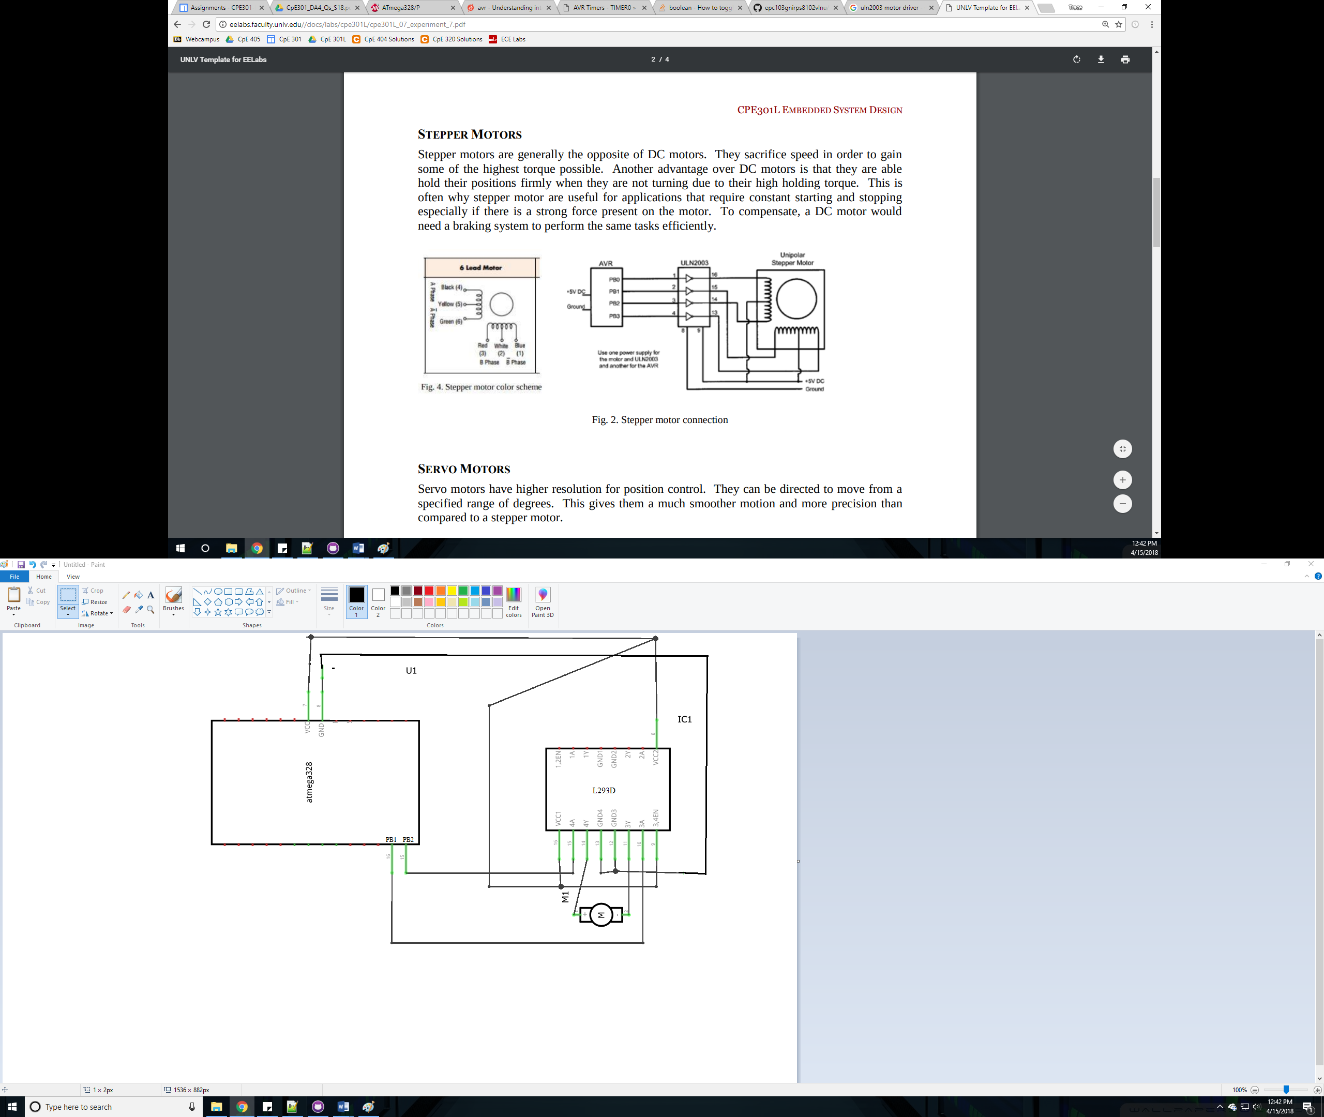

Stepper Motor

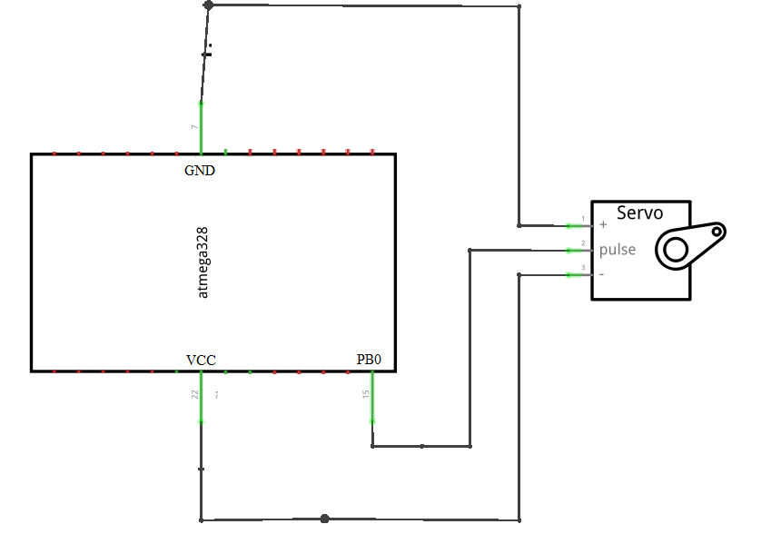

Servo Motor

1. **CODE OF TASK 1**

/*

* GccDA4BT1.c

*

* Created: 4/17/2019 7:14:09 PM

* Author : Home

*/

#include <avr/io.h>

#include <avr/interrupt.h>

#define F_CPU 8000000L

#include <util/delay.h>

#include <stdlib.h>

volatile int ovrflw; // global variable for keeping track of # of times Timer0 overflows

volatile uint8_t ADCvalue; // Global variable, set to volatile if used with ISR

int main(void)

{

DDRB = 0xFF;

// initialize ADC

DDRC = 0; // Set PORTC as input for adc

DIDR0 = 0x1; // Disable digital input on ADC0 pin

ADMUX = 0; // ADC0 (PC.0) used as analog input

ADMUX |= (1 << REFS0); // use AVcc as the reference

ADMUX |= (1 << ADLAR); // Right adjust for 8 bit resolution

ADCSRA = 0x87; // Enable ADC, system clock, 10000111

ADCSRB = 0x0; // Free running mode

// set up timer with prescaler = 64 and CTC mode

TCCR1B |= (1 << WGM12)|(1 << CS11)|(1 << CS10);

// initialize counter

TCNT1 = 0;

// initialize compare value

OCR1A = 0;

// enable compare interrupt

TIMSK1 |= (1 << OCIE1A);

while(1)

{

ADCSRA |= (1 << ADSC); // Start conversion

while((ADCSRA&(1<<ADIF))==0); // Wait for conversion to finish

if(ADCH < 245){

ADCvalue = ADCH + 10; // Only need to read the high value for 8 bit then equation for Fahrenheit

PORTB = 0x0C;

sei();

PORTB = 0x09;

sei();

PORTB = 0x03;

sei();

PORTB = 0x06;

sei();

}

}

}

ISR (TIMER1_COMPA_vect) {

for(int i=0;i<=ADCvalue;i++)

{

_delay_ms(1);

}

}

1. **CODE OF TASK 2**

/*

* GccDA4BT2.c

*

* Created: 4/17/2019 7:24:38 PM

* Author : Home

*/

#define F_CPU 8000000L

#include <avr/io.h>

#include <util/delay.h>

#include <avr/interrupt.h>

int main(void)

{

// initialize ADC

DDRC = 0; // Set PORTC as input for adc

DIDR0 = 0x1; // Disable digital input on ADC0 pin

ADMUX = 0; // ADC0 (PC.0) used as analog input

ADMUX |= (1 << REFS0); // use AVcc as the reference

ADMUX |= (1 << ADLAR); // Right adjust for 8 bit resolution

ADCSRA = 0x87; // Enable ADC, system clock, 10000111

ADCSRB = 0x0; // Free running mode

//Configure TIMER1

TCCR1A|=(1<<COM1A1)|(1<<COM1B1)|(1<<WGM11); //NON Inverted PWM

TCCR1B|=(1<<WGM13)|(1<<WGM12)|(1<<CS11)|(1<<CS10); //PRESCALER=64 MODE 14(FAST PWM)

ICR1=4999; //fPWM=50Hz (Period = 20ms Standard).

DDRB|=(1<<PB1); //PWM Pin as Out

while(1)

{

ADCSRA |= (1 << ADSC); // Start conversion

while((ADCSRA&(1<<ADIF))==0); // Wait for conversion to finish

//OCR1A=75; //90 degrees

//OCR1A=290; //0 degrees

OCR1A = (ADCH * 5 / 6) + 75;

}

}

1. **Schematic**

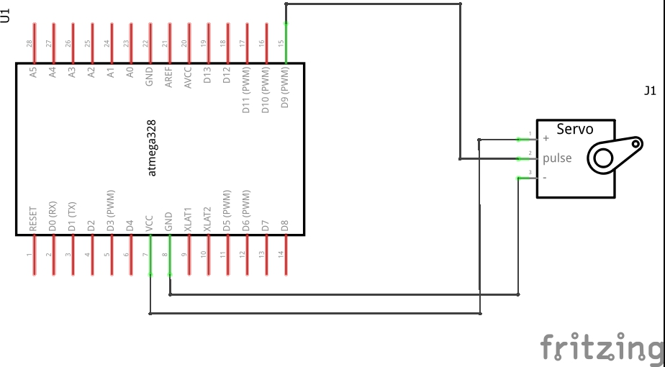

Servo Motor

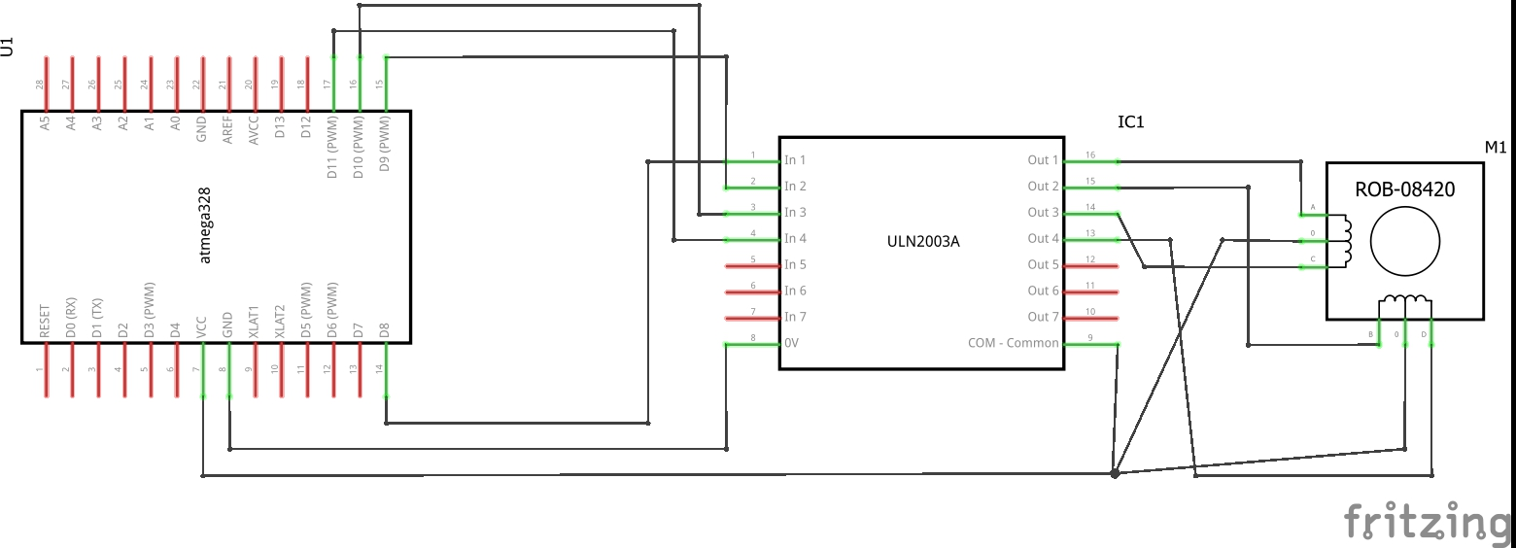

Stepper Motor

1. **SCREENSHOTS OF EACH TASK OUTPUT (ATMEL STUDIO OUTPUT)**

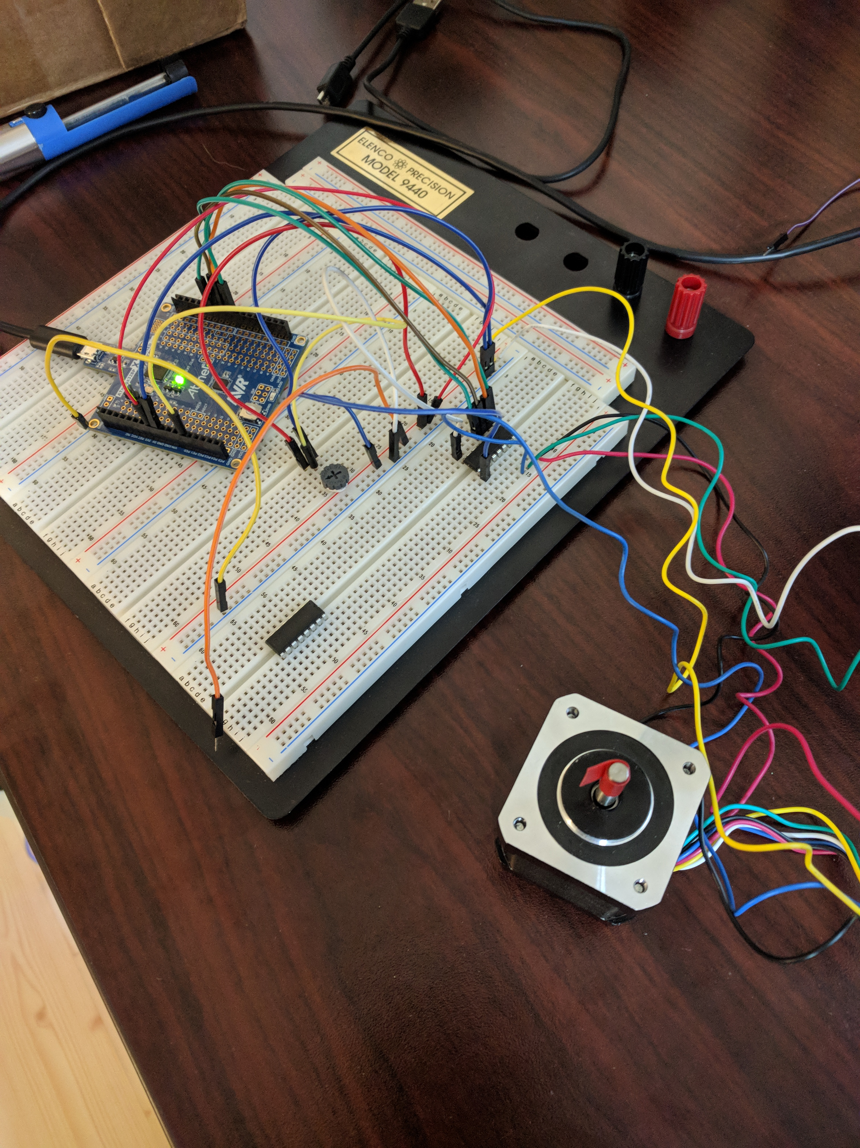

Stepper Motor

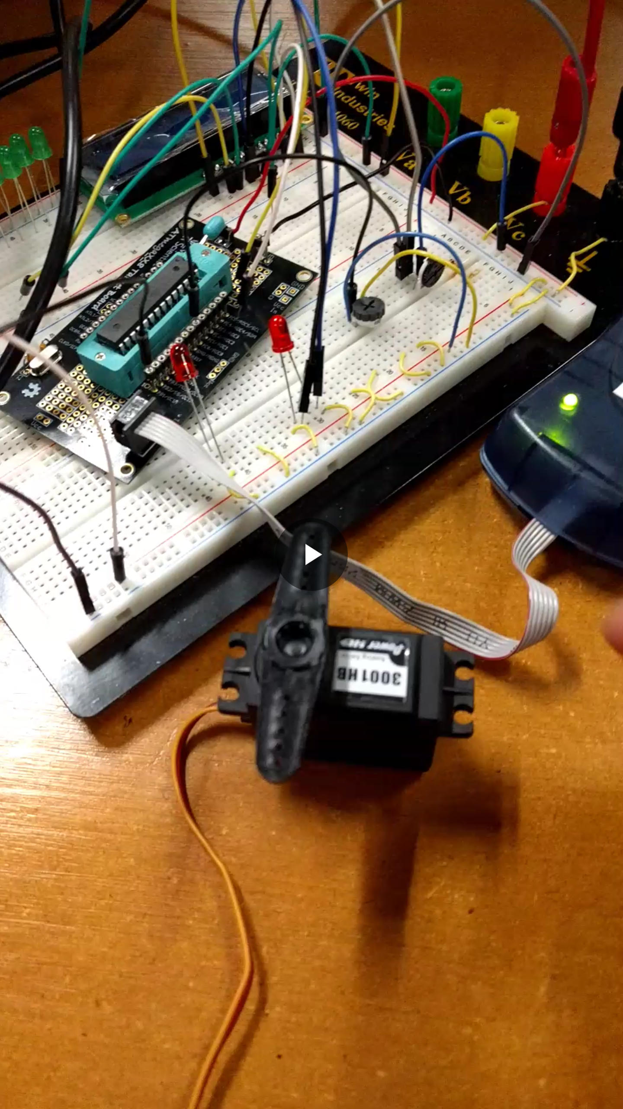

Servo Motor

1. **VIDEO LINKS OF EACH DEMO**

<https://youtu.be/l_GeOdkJkjw>

1. **GITHUB LINK OF THIS DA**

<https://github.com/sawar1/UNLV301>

**Student Academic Misconduct Policy**

<http://studentconduct.unlv.edu/misconduct/policy.html>

“This assignment submission is my own, original work”.

RIMON SAWA